**CRM SALES (MICROSOFT EXCEL)**

**Summary**

The purpose of this data analysis is to seek insight from the CRM sales dataset that can lead to increasing sales opportunity. The dataset revealed the need for on-time documentation of prospective clients.

**Details About Dataset**

This dataset presents the details of CRM sales opportunities contained in five tables stored in Microsoft Excel format (.xlsx). The tables are accounts, sales pipeline, sales teams, products, and data dictionary.

The accounts table contains customer accounts details, sale pipeline table contains the details about sales, sales teams table contain details of the sales agent, the products table contain details about the products, and the dictionary table contains the details of the tables and the columns in each table.

**Data Analysis**

The dataset shows that the registered “prospective” customers are three times less than “engaged” customers, and they are from two managers only out of six managers. The won deals are two times that of the lost deals and majority of the customers are based in the United States. The data also shows that the customers made more decisions about the product before a month from time of presentation. GTX-BASIC is the most requested product while the GTK-500 is the least requested.

**Recommendation for Growth**

From the dataset, we see that more decisions concerning deals were concluded before a month time from the time of presentation. This indicates that presentation of products to prospective customers has to be very accurate, which implies that a lot of effort has to be made to understand the customer and the needs of the customer before approaching the customer, and this requires research and preparation. Due to the need for this research and preparation before meeting the customer, information about prospective customers is needed. It is suggested that all managers and sales agents should locate and register their prospecting clients on time, as this will be used for intense research on the customers to understand their needs, requirements, budget, etc.

**Screenshots of Project**

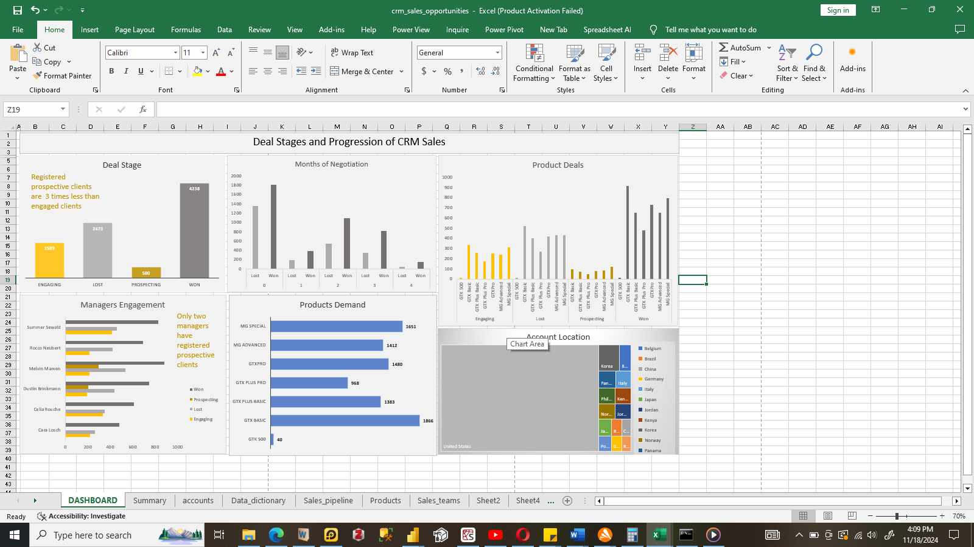

Fig1 – Dashboard

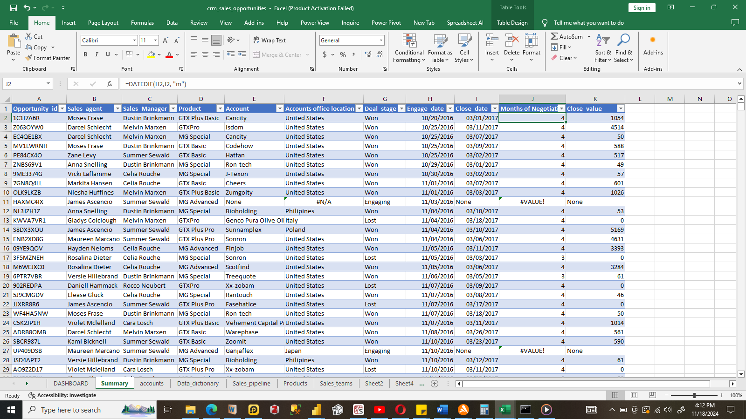

Fig 2 - Table